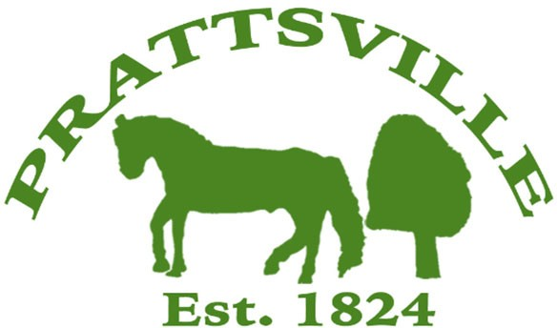Town of Prattsville Board Agenda

Regular Monthly Meeting

October 15th, 2024

1. CALL MEETING TO ORDER
   * Pledge of Allegiance
   * Roll Call
2. APPROVAL OF CLERK'S MINUTES
   * Regular Meeting – September 9th, 2024
3. APPROVAL OF MONTHLY FINANCIALS REPORT
4. COMMENTS FROM THE FLOOR / CORRESPONDENCE FROM THE COMMUNITY

# Old Business / Reports

1. Highway
2. Water District Report
3. Code Enforcement Monthly Report
4. WWTP Report
5. Zadock Pratt Museum Report

# New Business

1. Delinquent Water Bills
2. Delinquent Sewer Bills
3. Letter from resident
4. Commercial building / Pratt Rock Park
5. Town Use form
6. Tax Cap Override
7. Budget Workshops
8. Lamont Contract